**Fifty-Sixth Student Senate**

**26th Meeting Agenda**

**January 16th, 2025**

* **Call to Order**
  + 7:15 PM
* **Roll Call and Verification of Quorum**
  + Quorum: 42/45
  + Present and Voting:
    - 7:42 PM - Widerberg
    - 8:28 PM - Wangen
    - 10:43 PM - Richmond
* **Approval of the Minutes** – [01/09/2025;](https://ucf.sharepoint.com/:w:/r/sites/UCFTeam-StudentGovernment_GRP-SGLegislative-Senate/Shared%20Documents/SG%20Legislative%20-%20Senate/Agendas/25th%20Meeting%20Agenda%2001.09.2025.docx?d=wacb3d587e9f74ffea0c4bcbc2f5155d6&csf=1&web=1&e=5lIrgd)
* **Approval of the Agenda –** 01/16/2025;
* **Open Forum**
  + Soon-to-be senator introducing themself.
* **Announcements from the Student Body President (Bryce Lister,** [*sga_pres@ucf.edu*](mailto:sga_pres@ucf.edu))
  + Good MORNING Senate! I hope you all have had a good first two weeks of classes, (and actually attending lectures)
  + This week, we had our first Cookies with a Cop event on Monday 1/13, the first Green Assembly on Tuesday 1/14, the Work Where You Learn Fair on Wednesday 1/15, and the Spring Sports Pep Rally today Thursday 1/16. So thank you to Safety and Transportation Coordinator Lisman, Sustainability and Innovation Coordinator Commorato, Chief of Staff Blanco and Athletics Coordinator Wetzler for planning and facilitating these events.
  + Also, on Saturday we will have a mechanical rocket for the basketball block party at Knights Plaza, as well as worked with UCF Athletics to give out some special SpaceU SG shirts in the student section during the 12:00 pm Men’s Basketball game against Houston.
  + I also will hereby appoint the following individuals to their respective positions:
  + Dinmukhamed Muratov to College of Engineering and Computer Science Seat 2
  + Niklas Luecht to College of Engineering and Computer Science Seat 8
  + Tyler Borges to Rosen College of Hospitality Management Seat 2
  + Alyssia Wright of the Election Commission to serve as the Assistant Supervisor of Elections.
  + Also, due to a change of major I will be reappointing Danishka Morisette to serve in the College of Undergraduate Studies Seat 2

**Announcements from the Student Body Vice President (Alexander Brawley,** [*sga_vp@ucf.edu*](mailto:sga_vp@ucf.edu))

* + Good evening I apologize for not being here in person I am sick. This week our communication plan with Parking Services began for our Pay With Provisions program with more collaborative posts coming soon. On Friday I am meeting with Director Meyer from SAS tomorrow morning to discuss a golf cart service for ADA students and I will be attending the Disability Caucus meeting at noon to hopefully find some points of collaboration there. Additionally, I am meeting with the Universities Chief Compliance Officer next week to discuss the golf cart imitative mentioned earlier as well as the emergency response procedures in the syllabi. I will also be speaking to the Faculty Senate Campus Safety and Security Committee at the end of the month regarding both those initiatives. I unfortunately do not have an update on the Interfaith Council right now as I am still awaiting the feedback from several individuals Thank you and have a nice weekend
* **Comptroller’s Report (Kylie Cimillo,** [*sga_comp@ucf.edu*](mailto:sga_comp@ucf.edu))
  + Hi everyone!! I hope everyone is super excited for the long weekend we have ahead of ourselves!
  + I wanted to remind everyone again of the fiscal workshop coming up February 11th from 11-12 and 6-7 and to email your RSOs to make sure they are checking the Instagram to register. I have already sent the request to comms so it'll be coming shortly!!
  + This week during Military and Veterans Caucus we discussed a few events and resolutions we have in the works. I am currently working with Sofia Lisman the safety and Transportation coordinator, to hold an event during safety week with the k9 unit. I hope this comes to fruition as I and I am sure everyone else would love to see all the cool party tricks the dogs can do!
  + The executive branch recently met to go over mid-year budget evaluations to ensure we are working well and efficiently to use our funds and get all of our initiatives funded properly. I can't wait to see where this semester takes us!
  + I have a meeting with Luke Brown from EC to go over budget and how we plan to get people excited for the elections. We plan on discussing how to use our money diligently for this fiscal year but also stretch itr as far out as we can to get the best reach!! We would love love love your insight before this meeting so when you have the chance to please fill out this google form to best help Lukes team and us to budget correctly! We would appreciate that this is completed by Monday
  + [Election Comms Insight Form](https://docs.google.com/forms/d/e/1FAIpQLSf6oJDIkq5tOAf3adGRrlC7EVwbPdFQOm3UcVE5chmSw2qywA/viewform)
  + FAO: $56,530.04 Reversion of 1.35%
  + CRT: $120,475.32 Reversion of 0.77%
* **Attorney General's Report (Jonathan Polera,** [*sga_ag@ucf.edu*](mailto:sga_ag@ucf.edu))
  + Good EVENING Senate! I updated Senate Rule 2 in accordance with 56-10, Title IX in accordance with 56-18, and Title III in accordance with 56-19. Hope you all have a great long weekend!
* **Cabinet Forum**
  + Director of Student Affairs, Jarib Benitez ([sgastaffairs@ucf.edu](mailto:sgastaffairs@ucf.edu))
    - Hello Senate! I hope everyone is having an amazing start to the Spring semester.
    - I have started the planning efforts for Universal Knights since it is sooner than normal. This year, it will be February 23rd, more information with distributions and volunteer shifts will come next week via your SG emails along with the promotion on our Instagram.
    - The student affairs division is in full force as well with events, with coordinators hosting 4 events just this week alone, and many more to come within the month.
    - Now this message is coming from our Diversity and Inclusion Coordinator, Jasmine Kaur, who could not make it tonight. “Hey guys, I’m trying to plan a SG caucus takeover, one of my main initiatives when I got confirmed in this position was to bring representation to the caucus. We will table at the student union atrium February 10th 12-3 if this date works for all caucus. I have sent out an email, if all the chairs could please respond at their earliest convenience, so we can start planning the event! More details are in the email and if you would like to help or attend please reach out to me!”
    - Other than that, if you have any questions or concerns- feel free to email me!
* **Announcements from the Chief Justice (Daniel Rivera,** [*sga_cjus@ucf.edu*](mailto:sga_cjus@ucf.edu)*)*
  + Hi Senate! Judicial is chugging along:
    - Branch Retreat – Saturday
    - USF Visit – late January
    - Lounging with a Lawyer – early February
  + For anyone who needs Judicial’s services, please find all [[our forms here](https://knightconnect.campuslabs.com/engage/organization/sga-judicialbranch)](https://knightconnect.campuslabs.com/engage/organization/sga-judicialbranch)!
  + I hereby resign:
    - Women’s Caucus
      * Justice Nerro
      * Justice Pazera
      * Justice Villadarez
      * Justice Calfee
    - Latin/Hispanic Caucus
      * Justice Nerro
      * Justice Porlles
* **Announcements from the Supervisor of Elections (Luke Brown,** [*sga_ec@ucf.edu*](mailto:sga_ec@ucf.edu))
  + Hi Senate, I hope you are having a great evening. I have a few announcements for this evening. In the last meeting I forgot to mention the due date of all application packets is actually the 14th of February.
  + Along with this I want to make the Senate and any students that choose to view these minutes of an ongoing situation being handled by the Election Commission for the sake of transparency. Over Winter Break, multiple Election Commsioners and I were made aware of a pair of students aiming to become presidential candidates who had created an Instagram in an effort to gain signatures. On January 7th I, as the Supervisor of Elections, requested these individuals take down their Instagram until further notice, this was in order to allow time for the commission to deliberate on our next course of action. These individuals agreed to this request and took down their account immediately, along with becoming significantly more communicative with the commission. On Tuesday this week during our first meeting the commission deliberated and decided that IF this group meets the requirements to become a ticket by collecting the necessary 100 signatures, along with the completion of the presidential packet, and attending their info session. The commission will begin the process of an Election Violation Hearing. These individuals have been made aware of this fact. If anyone believes they have new information to share that the commission may not have we ask that file an affidavit that includes the necessary requirements. I want to preface. There is nothing the commission can currently do or enforce upon these individuals as they are technically not even candidates yet. The commission can only take action if a student or group are actively candidates.
  + Thank you, if you have any questions, please let me know! I hope to see some of you tomorrow at our first info session or one of the following ones:
    - 1/17/2025 12:30 in SU 220
    - 1/22/2025 5:30pm in the SG Conference Room
    - 1/31/2025 1:30 PM in SU 220
    - 2/3/2025 4:00 PM in the Charge on Camber
    - 2/5/2025 1:30 PM in SU 220
    - 2/7/2025 12:30 PM in SU 220
    - 2/10/2025 1:30 PM in SU 220
    - 2/12/2025 1:30 PM in SU 223
    - If you are not available for any of these, you are welcome to request a zoom session.
    - Presidential candidates are also asked to send me an email to schedule an info session specifically for them.
  + Also the link Kylie shared is fixed so everyone should be able to access it now!!
* **Announcements from the Activity and Service Fee Committee Chair (Adam Caringal,** [*sga_asf@ucf.edu*](mailto:sga_asf@ucf.edu))
  + Hiiiiiiiiiiiiiiiiiiiiiiiii
  + So not much, just sent a [when2meet](https://www.when2meet.com/?28335440-h79tj) for proviso language we’ll do next week. That’ll leave another week in between in case we need to meet again. That’s all can’t wait for the budget session on 2/6!
* **Announcements from the Scholarship Committee Chair (Panayiota Lailotis,** [*sga_scholarship@ucf.edu*](mailto:sga_scholarship@ucf.edu))
  + None
* **Caucus Reports**
  + **Asian/Pacific Islander American Caucus (Chair Jaci Lim,** [*sgapiacaucus@ucf.edu*](mailto:sgapiacaucus@ucf.edu))
    - Hi everyone! We elected a new vice chair, congrats to vice chair Chauhan! We discussed the next steps of our APIA catering initiative and we plan on setting another meeting with dining services to discuss improvements and future plans. Thanks everyone!
  + **Black Caucus (Chair Jordan Metellus,** [*sgblackcaucus1@ucf.edu*](mailto:sgblackcaucus1@ucf.edu))
    - Good evening Senate! I hope you are all doing well. Black Caucus met last week where we discussed initiative updates. Our next meeting will be tomorrow. Progress has been made on our Black History Month Initiatives will the Black Business Showcase flyer and registration form being released soon. Pro Temp Morisette has been working to get our food truck fridays set up and many details such as potential restaurants are in the works. Chair Johnson and I as well as Pro Temp Morisette are set to meet with Dr. Guzman to discuss data and details related to Juneteenth initiative. Black Caucus will meet tomorrow in the conference room at 11am. Thanks guys!
  + **Disability Caucus (Chair Autumn Johnson,** [*sgdisabilitycaucus@ucf.edu*](mailto:sgdisabilitycaucus@ucf.edu)*)*
    - Our first meeting will be tomorrow at noon in the SG conference room.
  + **Latin/Hispanic Caucus (Chair Camila Gimenez Valero,**[*sglatinxcaucus@ucf.edu*](mailto:sglatinxcaucus@ucf.edu))
    - Hello! Tomorrow we will be holding Chair elections at 9:30AM in the SG Conference Room tomorrow! Please join the caucus if you would like to get involved this semester, and let me know, if you haven’t already if you are interested in the leadership position! Let me know if you have any questions!
  + **LGBTQ+ Caucus (Chair Elle Beneche,**[*sglgbtqcaucus@ucf.edu*](mailto:sglgbtqcaucus@ucf.edu))
    - Heyyyy 😊 We had a meeting on Tuesday regarding our plans/future proclamations for the spring semester so stay tuned. Also, we may be tabling at the Women’s Health Fair on Tuesday!! Next meeting is the 28th at 9am
  + **Military & Veterans Caucus (Chair Andrew Collazo,** [*sgmvcaucus@ucf.edu*](mailto:sgmvcaucus@ucf.edu)*)*
    - The Military and Veterans Caucus met this past Tuesday. Reminder that the Caucus meets biweekly on Tuesdays @ 12:30 PM. Since we met this week, we won’t meet next week. So, our Next meeting is on the 28th. Reminder to Join the caucus you must be appointed by the branch head,
    - In the meet we discussed Spring events. These events include Salute to Women Veterans on March 6th, Month of the Military Child in April, and Memorial Day in May.
    - The Web course initiative that was introduced last semester is halfway complete. This webcourse will allow military students to get involved and recertify their benefits.
    - Proclamations on out priority list are K-9 Veterans Day; March 13th, Vietnam Veterans Day; March 29th, April- Month of the Military Child, Memorial Day: May 27th, Salute to Women Veterans Ceremony: March 6th.
    - Comptroller Cimillo in collaboration with the Caucus will be planning an event to have the K-9 units here are UCF present during Safety week.
    - Iron Knight is the 22nd of February, I am having discussions with the Director of Student Affairs to see if we can supply water.
    - Air Force will be hosting the Dining Out Gala on 3/29 and the Commissioning Ceremony on 5/4. Which will be the Vice Chair’s commissioning ceremony.
    - I have spoken to Director Kepner, and the VA is very slow, so they are backed logged on certifications right now. So, if you have a friend that is a military student and they are still waiting for their benefits, please let them to be patient and that their benefits are coming.
    - Lastly, Caucus Chairs should have received an email from the DEI coordinator about an atrium taker over. I was able to finally meet with the coordinator and discuss the plans for the events. Please answer her email.
  + **Women’s Caucus (Chair Amanda Lazo,** [*sgwxmenscaucus@ucf.edu*](mailto:sgwxmenscaucus@ucf.edu)*)* 
    - Seeing a Proclamation today for National Cervical Cancer Awareness Month
    - Had our first (very efficient) meeting today, as a reminder, meetings are now at 12:00 on every other Thursday with our next meeting being on 1/30.
    - Very excited for our Women's Health Fair next week here in the Student Union Atrium from 12PM-4PM.
      * If you’re interested in volunteering for either SBA/GAP/LGBTQ Caucus tabling or setting up/breaking down the event, fill out this When2Meet!
      * <https://www.when2meet.com/?28413572-VR1ba>
  + **Arab Ad Hoc Caucus (Chair Haleema Al-Qudah**, [*sgarabcaucus@ucf.edu*](mailto:sgarabcaucus@ucf.edu))
    - Hello Senate!
    - Tabled at the grand opening of the Halal Shack, met the CEO, reached hundreds of students throughout the day who also got to sample the menu. Spoke with some RSOs present and we agreed that with this opening and expanding of accessibility to food restrictions many students have, there can be more education on what halal food is. Additionally, working on collaborating with RSOs to get Arab restaurants into Restaurant Row.
    - Still working on getting a meeting time arranged as I unfortunately have only received feedback from one official member of the caucus. As a general reminder now that we are getting back into the swing of things, for quorum purposes, please keep communication flowing with caucus leadership you are a part of to be considered an active member. We will begin meeting weekly and have a set meeting time next week, so please make sure you keep an eye on the Teams channel. Thank you!
  + **Sustainability Ad Hoc Caucus (Chair Aiden DiChiara**, [*sgsustaincaucus@ucf.edu*](mailto:sgsustaincaucus@ucf.edu))
    - Met with Ryan Chabot and Jennifer Elliot of the Arboretum to discuss the next steps for the caucuses initiatives
    - Met on Wednesday to discuss resolution writing, meeting review, and how we as a caucus can help improve UCF’s STARS rating
    - [UCF Report](https://reports.aashe.org/institutions/university-of-central-florida-fl/report/2024-04-23/) - <https://reports.aashe.org/institutions/university-of-central-florida-fl/report/2024-04-23/>
    - [Meeting Notes](https://ucf.sharepoint.com/:w:/s/UCFTeam-StudentGovernment_GRP-SGSustainabilityAdHocCaucus/EX2C1wkaakhMrPLUmRDzbSIBR6jNDc6kOrXJ5bT-R5hCZQ?e=X9QxQa)
    - We meet weekly on Wednesday at 4:30 in the Conference Room
  + **Inter-Campus & Transfer Ad Hoc Caucus (Chair Juan Varela**, [*sgitccaucus@ucf.edu*](mailto:sgitccaucus@ucf.edu))
    - Meeting tomorrow at 3:30!!
    - Big thanks to Chair Vasquez and Chair Hameed for covering a a tabling event for ICTC. I heard that it went great!!
    - I had a meeting with the Rosen Dean today and they are very happy to announce that they have a TED Talk symposium stage that is available for reservation at Rosen Campus Now! There were channel 13 news cameras to record its grand reveal and it is open to any Student Organization to reserve for events please spread the word! A flyer will be released with the next few weeks and if you have any questions please don’t hesitate to contact me
* **Announcements from the Senate President (Allison Pohlmann,** [*sga_spkr@ucf.edu*](mailto:sga_spkr@ucf.edu)*)*
  + Started scheduling meetings with other universities
    - Next week is UF zoom
    - UNF coming to visit on February 20th
    - Outreach events! Jan 29th and Feb 5th
    - <https://docs.google.com/forms/d/e/1FAIpQLScC9EDrc0sDefMncxzWnaRODm1XQUUsMV7_Ca-14GTl-HNYMw/viewform?usp=sharing>
* **Internal Legislative Assistant Report (Haleema Al-Qudah,** [*sgaila@ucf.edu*](mailto:sgaila@ucf.edu)**)** 
  + Hello again Senate! SLC met for the first time last Monday and it was a huge success! We’ve got a fantastic group, and I am so excited for this SLC session! Our meetings will continue every Monday at 4pm in the Charge on Chamber. Please remember to fill out the SLC Mentor Interest Form if you would like to be considered for a mentorship role this session and have this form filled out by end of day tomorrow. I am aiming to host a Mentor Social next week, likely before Senate to ensure the availability of as many of you as possible. As always, please don’t hesitate to let me know if you have any questions or need anything! Thank you!
  + SLC Mentor Interest Form:
  + https://forms.gle/HFWgGTkYJuKi3xrH8
* **External Legislative Assistant Report (Laurel Richmond,** [*sgaela@ucf.edu*](mailto:sgaela@ucf.edu)**)** 
  + None
* **Senate President Pro Tempore Report (Danishka Morissette,** [*sga_pro@ucf.edu*](mailto:sga_pro@ucf.edu)*)*
  + Meeting with Club Kreyol and Neg Kreyol tomorrow to walk them through fiscal procedure
  + Meetings for DLEG wrap up next week
  + Had a meeting with DSR Lazo today, fun events planned for you all!
  + Working on efficiency of tracking fiscal bills and legislation
* **Deputy Pro Tempore of Legislative Affairs Report (Vacant,** [*sga_dleg@ucf.edu*](mailto:sga_dleg@ucf.edu)**)**
  + None
* **Deputy Pro Tempore of Senate Relations Report (Amanda Lazo,** [*sgadsr@ucf.edu*](mailto:sgadsr@ucf.edu)**)** 
  + We have a bunch of upcoming events.
  + First is our January event, Game Knight!
    - 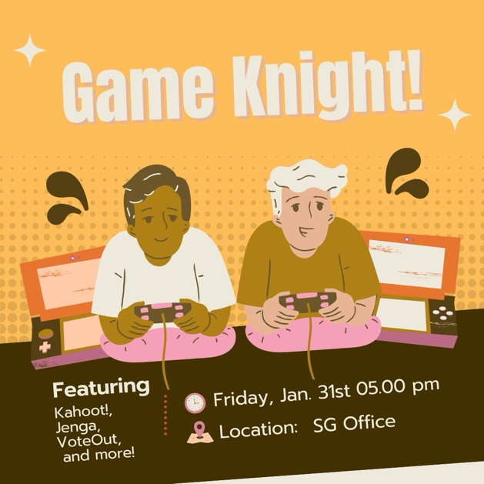
  + We also have a Valentines Event in the works, I’ll drop a cute little flyer but this isn’t set in stone yet.
    - 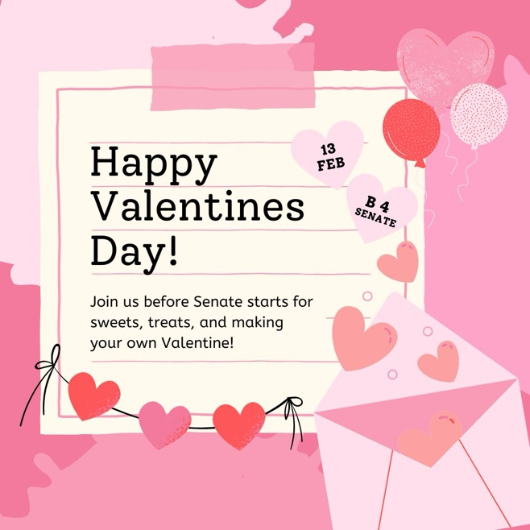
  + Soccer is wrapping up, last game is next week, Andrea is an incredible goalie so give it up for her!
    - Fill out this form for Spring IMs
      * <https://forms.gle/SqPD9EFGMZVFyR9C9>
      * And here’s a pic from Tuesday’s game! Chair Courts was the MVP she is the number one striker.
      * 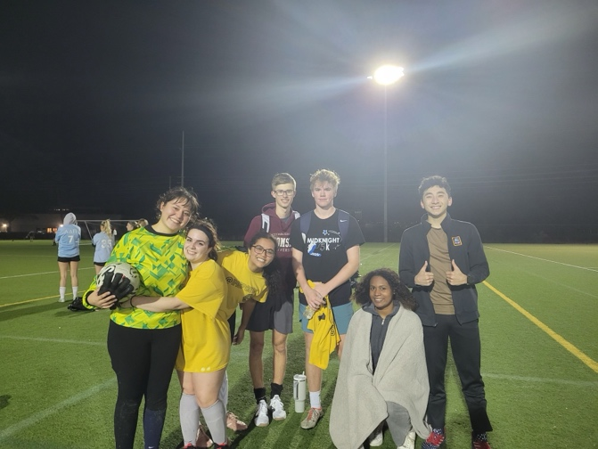
* **Old Business** 
  + Motion of No Confidence; **Failed 12-30-2**
    - [Relevant Materials](https://ucf.sharepoint.com/:f:/s/UCFTeam-StudentGovernment_GRP-SGLegislative-Senate/EgbAdsGoXtpBki9nlkTkn4AB1yXtljDO_EeoQ6m5ZupVaQ?e=Wp7IC0)
* **Fiscal Committee Caucus Time**
  + None
* **Fiscal Committee Reports**
* **CRT Committee (Chair Adam Caringal,**[*sga_crt@ucf.edu*](mailto:sga_crt@ucf.edu)**)**
  + Omg hi againnnnnnnn, in committee, we:
    - Approved 56-: 399, 402, 407, 408, 409, 411-419, 422, 423, 424, 426, & 427
    - Postponed 56-: 405, 406, 410, 420, & 421
    - PPI’d 56-: 389, 395, & 425
  + Also, ty Ryan for letting me know MLK day is indeed Monday, and we will not have classes sooooo if you are on the committee, fill this [when2meet](https://www.when2meet.com/?28447103-3brVT) out.
* **FAO Committee (Chair Ryan Kaufman,** [*sga_fao@ucf.edu*](mailto:sga_fao@ucf.edu))
  + We had a great meeting on Tuesday.
    - Approved 56-: 128, 134-140, 142-154
    - Postponed 56-141
* **ORS Committee (Chair Samuel Rose,** [*sgaors@ucf.edu*](mailto:sgaors@ucf.edu))
  + First meeting tomorrow at 2.
* **Fiscal Legislation**
* **Notice of Legislation on First Reading** 
  + Bills
    - [Fiscal Bill 56-41](https://ucf.sharepoint.com/:w:/s/UCFTeam-StudentGovernment_GRP-SGLegislative-Senate/EZdqR-94dZBNmQdVsoth63QBfP3TiWxWEaCQ0EMn8aqgBQ?e=gGT89p) [Funding for 6 members of Criminal Justice Graduate Student Association to travel to the Academy of Criminal Justice Sciences in Denver, Colorado from March 11th 2025 to March 15th 2025] [Vice Chair Varela] **Remanded to CRT**
    - [Fiscal Bill 56-42](https://ucf.sharepoint.com/:w:/s/UCFTeam-StudentGovernment_GRP-SGLegislative-Senate/ESlpV7wBIo1PpS6psivPUbgBaQsr04aC1w8i9D2Luu3Eow?e=kESS3Q) [Funding for 9 members of MEDLIFE to travel on a Service-Learning Trip in Tamarindo, Costa Rica from March 15th, to March 23rd, 2025] [Senator Widerberg] **Remanded to CRT**
    - [Fiscal Bill 56-43](https://ucf.sharepoint.com/:w:/s/UCFTeam-StudentGovernment_GRP-SGLegislative-Senate/ERgU70cnGe5PhbfLTk8LY0EBi5Z2AchLvarfkDIEpoimMQ?e=7a192G) [Funding for 12 members of Future Theme Park Leaders of America to travel to the FTPLA Europe Executive Management Shadow Week in Europe (France, Germany, Netherlands) from April 1st, 2025 to April 12th 2025] [Senator Rubin] **Remanded to CRT**
    - [Fiscal Bill 56-44](https://ucf.sharepoint.com/:w:/s/UCFTeam-StudentGovernment_GRP-SGLegislative-Senate/EcmU4xsEyZ9Hi77m93O5YxYBfv9H1VX62yVWVzNY_QzjrQ?e=hT0UCn) [Funding for 14 members of Student Nurses’ Association - Orlando to travel to the National Student Nurses’ Association 73rd Annual Convention in Seattle, Washington from April 8th, 2025 to April 13th, 2025] [Senator Greene] **Remanded to CRT**
    - [Fiscal Bill 56-45](https://ucf.sharepoint.com/:w:/s/UCFTeam-StudentGovernment_GRP-SGLegislative-Senate/EYmREHwU50xIrVx-kMyNtNkBPFnJGPJII9z62HC4D2TEiA?e=mi3Hul) [Funding for 15 members of Club on Security and Intelligence to travel to the CoSI at the Capitol 2025 in Washington, DC from March 31st, 2025 to April 4th, 2025] [Pro Temp Morissette] **Remanded to CRT**
  + Resolutions
  + Special Acts
* **Notice of Legislation on Third Reading** 
  + Bills
  + Resolutions
  + Special Acts
* **Notice of Legislation on Second Reading** 
  + Bills
    - [Fiscal Bill 56-40](https://ucf.sharepoint.com/:w:/s/UCFTeam-StudentGovernment_GRP-SGLegislative-Senate/ETD2z0sv39NJl8d6-Qr4dE8Bd5uqnFZ3HtFeSSZ9UZbCjg?e=9kiJJ0) [Funding for Air Force ROTC to host the Spring 2025 Dining Out in the Pegasus Ballroom on March 29th, 2025] [Chair Kaufman] **Passed 37-0-2**
  + Resolutions
  + Special Acts
* **Internal Committee Caucus Time** 
  + None
* **Internal Committee Reports**
* **E&A Committee (Chair Aiden DiChiara,** [*sga_ea@ucf.edu*](mailto:sga_ea@ucf.edu)*)*
  + Saw 1 confirmation and 2 bills
    - Internal Bill 56-26 [Updates to Title VI: The Election Code of Ethics] [Senator Escobar]
      * **Passed favorably**, 9-0-0
    - Internal Bill 56-27 [Updates to Title IV: Timeline for Appointments for Student Government Offices] [Vice-Chair Varela]
      * **Passed favorably**, 4-3-1
    - Jessica Vitarelli for Election Commission Seat #7
      * **Confirmed by E&A**, 8-0-0
  + Additionally went over Title VI changes and bill progress
* **GAP Committee (Chair Andrea Vasquez,** [*sgagap@ucf.edu*](mailto:sgagap@ucf.edu)**)**
  + Hi Senate! We had our first meeting of 2025 today, it was a fun meeting, we finalized the Legislative Priority Survey, and I will submit it to publish, pending some final edits, by next week. We also Discussed methods of distribution to get as many people as possible to fill it out, so expect to hear me remind you to fill it out, once it is published. We also assigned research groups for our topics, very exciting stuff! Let me know if you have any questions!
* **LJR Committee (Chair Kirsten Courts,** [*sga_ljr@ucf.edu*](mailto:sga_ljr@ucf.edu))
  + Hello Senate!! I hope your first week of actual class work has been well 😊
  + Saw 6 Absences
    - Michael Shen, Anna Reed (2), and Adam Caringal: Approved 5-0-1
    - Merium Neguib: Approved 4-0-2
    - Joshua Hendry: Approved 3-0-3
  + Also saw 2 blanket excuses
    - Cameron Renda: Approved 5-0-1
    - Katrina Wangen: Approved 3-2-1
  + All of the LJR Representative positions have been filled; I will be representing in E&A, Senator Gaudio in SBA, and Senator Benwick in GAP. Thank you to both Senators Benwick and Gaudio 😊
* **SBA Committee (Chair Jason Hameed,** [*sgasba@ucf.edu*](mailto:sgasba@ucf.edu)*)*
  + Hello everyone! I hope you’re all having a great week. SO to my partner Alex as it is our 2 year anniversary.
  + This week we saw proclamation 56-25 which passed on first reading.
  + This past Tuesday we tabled at the opening of Halal shack in the SU. We were able to talk to a lot of students about our branch and everything we do for them. Thank you to Chair Vasquez, ILA Al-Qudah, Chair Lim, DSR Lazo, and Chair Kaufman for helping with tabling!
  + I also helped ICTC with tabling this past Wednesday for a transfer student event where I got a lot of new responses on the concern form!!
  + Next Tuesday we will also be tabling at the women's health fair!
  + Please let me know if you need any help with initiatives or proclamations/resolutions!
* **Confirmations**
  + [Confirmation Materials](https://ucf.sharepoint.com/:f:/r/sites/UCFTeam-StudentGovernment_GRP-SGLegislative-Senate/Shared%20Documents/SG%20Legislative%20-%20Senate/Confirmation%20Materials?csf=1&web=1&e=6n6QM6)
  + [1/15/2025 E&A Meeting](https://ucf.sharepoint.com/:w:/s/UCFTeam-StudentGovernment_GRP-SGLegislative-EA/EQsToKsE4_VNlIeA30i6_LUBJT_jz2DlzQr1DC8PeAo_rw)
  + Jessica Vitarelli – Election Commission Seat #7; **Confirmed 39-0-1**
  + Danishka Morissette - College of Undergraduate Studies Seat #2 **Confirmed 39-1-1**
* **Internal Legislation**
* **Notice of Legislation on First Reading** 
  + Constitutional Amendments
  + Bills
  + Resolutions
  + Proclamations
    - [Proclamation 56-26](https://ucf.sharepoint.com/:w:/s/UCFTeam-StudentGovernment_GRP-SGLegislative-Senate/EUvjhHObkbxPt5tPQ3HgjpEB_ykR-1BxcoOC0fJuQ5ELJw?e=jSqdWM) [Proclamation Commemorating the Exemplary Life and Achievements of Harris Rosen] [Vice-Chair Varela] **Remanded to SBA**
  + Special Acts
* **Notice of Legislation on Third Reading** 
  + Constitutional Amendments
  + Bills
    - [Internal Bill 56-22](https://ucf.sharepoint.com/:w:/s/UCFTeam-StudentGovernment_GRP-SGLegislative-Senate/EeHtU16nrB9EtTA1N0Yj8qIBBk9Y2k_41A2EIG5TbuYLLQ?e=b6K0eE) [Updates to Title XIV: Establishing the Caucus Leadership Committee] [MVC Chair Collazo]
    - [Internal Bill 56-23](https://ucf.sharepoint.com/:w:/s/UCFTeam-StudentGovernment_GRP-SGLegislative-Senate/EV9UlTycFoBLrBvuXMu7tw4B5lSTMzrEzeKgiodGJqvmOA) [Updates to Title XII: Establishing the Executive, Judicial, Senate Committee] [LJR Vice Chair Collazo]
    - [Internal Bill 56-24](https://ucf.sharepoint.com/:w:/s/UCFTeam-StudentGovernment_GRP-SGLegislative-Senate/EcPit1nWAtpGgr2kNFnAaWsBJ-D0acFnLJBhFfHQWg0BMw?e=wkUrbk) [Updates to VI: Allowing Election Commissioners to Hold Caucus Leadership Positions] [Pro Tempore Morissette]
    - [Internal Bill 56-25](https://ucf.sharepoint.com/:w:/s/UCFTeam-StudentGovernment_GRP-SGLegislative-Senate/EYkTqAh77J5DiFiInxofbLkBBzAD64oY88QMxvHuUVK5Wg?e=ZeseW4) [Updates to Title III: Removal of Sergeant-at-Arms Replacement Timeline] [Chair DiChiara]
  + Resolutions
  + Special Acts
* **Notice of Legislation on Second Reading**
  + Constitutional Amendments
  + Bills
    - [Internal Bill 56-26](https://ucf.sharepoint.com/:w:/s/UCFTeam-StudentGovernment_GRP-SGLegislative-Senate/EbXGH_ipsj5EqdsJmZXo_x4BdVndhV0hQWScvOokQyE62A?e=Rm5sty) [Updates to Title VI: The Election Code of Ethics] [Senator Escobar]
    - [Internal Bill 56-27](https://ucf.sharepoint.com/:w:/s/UCFTeam-StudentGovernment_GRP-SGLegislative-Senate/Ee5YEb_8zvZMrR7BCpjPEjQBUxcWqQe9E3cAJrJ4-KUY_A?e=gxmGfg) [Updates to Title IV: Timeline for Appointments for Student Government Offices] [Vice-Chair Varela]
  + Resolutions
  + Proclamations
    - [Proclamation 56-25](https://ucf.sharepoint.com/:w:/s/UCFTeam-StudentGovernment_GRP-SGLegislative-Senate/EcbUluZCdrZBgZ9Tyi566OIBtPpiI95zKesn1a-XOF-VuA?e=n7rbfY) [Proclamation Declaring the Month of January as National Cervical Cancer Awareness Month] [Chair Amanda Lazo] **Passed 41-0-1**
  + Special Acts
* **Senate Forum**
  + Speaker Pohlmann
  + Chair Courts
  + Chair DiChiara
  + Senator Gaudio
  + Senator Gumerov
  + Senator Metellus
  + Senator Rodriguez
  + Senator Lipner
  + Beneche - At the end of the day, we are a team and I hope we can work toward collaboration, open communication and reconciliation.
* **Senate Deliberations**
* **Advisor’s Report** 
  + Brodie:
  + Maddie ([*sgasa@ucf.edu*](mailto:sgasa@ucf.edu)):
    - Im mr. website. If you dont like something, tell me. I am pretty confident that most people who teams message me know I respond with an action plan and have seen results. So if you dont like something... text me.
* **Miscellaneous Business**
  + Reinstatements
  + Elections
  + Appointments
    - Military and Veterans Caucus
      * Nina Rodriquez
  + Resignations
    - Women’s Caucus
      * Jaci Lim
      * Kirsten Courts
    - CRT
      * Autumn Johnson
    - Latin/Hispanic Caucus
      * Elle Beneche
* **Final Roll Call**
  + 46/49
* **Adjournment**
  + 11:48 PM