**Fifty-Sixth Student Senate**

**12th Meeting Agenda**

**July 18th, 2024**

* **Call to Order**
  + 6:01 PM
* **Roll Call and Verification of Quorum**
  + Quorum: 35/47
  + Present and Voting:
    - 6:04 PM- Barios
    - 6:04- Rose
    - 6:14 PM – Johnson
    - 6:18 PM- J. Larson
    - 6:43 PM- Beneche
* **Approval of the Minutes** – [07/11/2024](https://ucf.sharepoint.com/:w:/s/UCFTeam-StudentGovernment_GRP-SGLegislative-Senate/EVoyo6Ctn-NDik5tgCM-Y6oBHoYmGpbjAPx-nBaLcwMVpw?e=Dc0k1j); **Approved by GC**
* **Approval of the Agenda –** 07/18/2024; **Approved by GC**
* **Open Forum**
  + None
* **Announcements from the Student Body President (Bryce Lister,** [*sga_pres@ucf.edu*](mailto:sga_pres@ucf.edu))
  + Hey everyone! Hope you had a great week since last Thursday. This past week, myself and Jasmine (D&I Coordinator) met with the Director of Counseling and Psychological Services to see how we can collaborate this year! Myself and Jarib also met with the Office of Military and Veteran Student Success to discuss SG involvement in their 2nd Annual 9/11 Memorial Event. Today I attended a UCF PD Swearing In and Promotion Ceremony. Additionally, myself and Wyatt (Athletics) were able to finalize some details with Athletics for RSO Sections at Football games, and right now it should be piloted at our home game against Cincinnati.
  + Lastly, I would like to appoint the following individuals to serve on the Election Commission:
    - Alyssia Wright for Seat 3 (They are returning)
    - Stefanie Henriques for Seat 2 (Also returning)
    - Norah Sackett for Seat 1
    - Aneesha Nayak for Seat 4
    - Amarah Presley for Seat 5
  + Thank you everyone! Have a great weekend!
* **Announcements from the Student Body Vice President (Alexander Brawley,** [*sga_vp@ucf.edu*](mailto:sga_vp@ucf.edu))
  + July 25th 2pm ADSPB
  + In & around finals week SU will open up and divvy up ballrooms for more study spaces for the student body. Furniture from the unused All Knights Study Room will be used to furnish spaces
  + Continuing communication with Rosen to better adjust shuttle services to coincide with their campus game day activities & main campus tailgates
  + I will leave it up to the coming weeks cabinet to provide greater detail but dates have been set for Winter Wonderland, MidKnight Breakfast, Midknight 5k, Cultural Fusion Festival, Serenity Stroll, Cookies with a Cop, Knights in the Know, & the Sustainability fair.
* **Comptroller’s Report (Kylie Cimillo,** [*sga_comp@ucf.edu*](mailto:sga_comp@ucf.edu))
  + FAO: $258,140.00 Reversion of 0%
  + CRT: $469,826.70 Reversion of 0%
* **Attorney General's Report (Jonathan Polera,** [*sga_ag@ucf.edu*](mailto:sga_ag@ucf.edu))
  + None
* **Cabinet Forum**
  + None
* **Announcements from the Chief Justice (Daniel Rivera,** [*sga_cjus@ucf.edu*](mailto:sga_cjus@ucf.edu)*)*
  + None
* **Announcements from the Supervisor of Elections (Vacant,** [*sga_ec@ucf.edu*](mailto:sga_ec@ucf.edu))
  + None
* **Announcements from the Activity and Service Fee Committee Chair (Vacant,** [*sga_asf@ucf.edu*](mailto:sga_asf@ucf.edu))
  + None
* **Announcements from the Scholarship Committee Chair (Vacant,** [*sga_scholarship@ucf.edu*](mailto:sga_scholarship@ucf.edu))
  + None
* **Caucus Reports**
  + **Asian/Pacific Islander American Caucus (Chair Jaci Lim,** [*sgapiacaucus@ucf.edu*](mailto:sgapiacaucus@ucf.edu))
    - Good evening everyone! Hope you guys are having a great week so far! This week I met with the APAC President, Lance Rances, to discuss future collaborations and ways the APIA Caucus can support them and how they can support us. I also had a meeting with the APAC Presidential Council where I got to meet their affiliated RSOs and hear about issues they would love to be addressed and their future events for this year. I also had a meeting with the Director of Communications to discuss adding a caucus highlight to the SG Instagram, which we plan to film and post a video introducing caucus leadership during the second or third week of the Fall semester. In this week’s meeting we discussed making a concern form and LinkTree, changing the questions and answers in the FAQ portion, and setting dates for our fall events. Thanks, everyone.
  + **Black Caucus (Chair Jordan Metellus,** [*sgblackcaucus@ucf.edu*](mailto:sgblackcaucus@ucf.edu))
    - Good evening everyone!! I hope you all have had a joyful and prosperous week so far. Last week Black Caucus discussed more details related to Black Business Month and some members took on some of their own initiatives and tasks to begin working on. I secured the date and time for the showcase: It will be August 22nd from 12-4. I’ve also created a vendor/RSO tabling registration form and sent it out to all of the RSOs in Black UCF. I’ve also reached out to Comms and a post for the event is in the works. We also discussed some suggestions for restaurants to be included in Local Restaurant Row during National Black Business Month in August. I will be meeting with Scotti Willis, Rick Falco, and other UCF Admin tomorrow to bring up these suggestions and finalize the initiative of having Black-Owned Restaurants in Restaurant Row. Remember to stay hydrated and drink water every day Thanks, everyone.
  + **Disability Caucus (Chair Mia Yracheta,** [*sgdisabilitycaucus@ucf.edu*](mailto:sgdisabilitycaucus@ucf.edu)*)*
    - Good evening! We had our first meeting this week, congratulations to Vice-Chair Johnson! We spent time discussing potential events and possible revisions to make to the website. Next week I am meeting with Adam Meyer, the director of Student Accessibility Services, to discuss collaborations. Hopefully, there will be further updates in the coming weeks.
  + **Latin/Hispanic Caucus (Chair Camila Gimenez Valero,**[*sglatinxcaucus@ucf.edu*](mailto:sglatinxcaucus@ucf.edu))
    - Good evening everyone! Sadly we did not meet quorum last week so we could not conduct any business, however our new meeting time is tomorrow and hopefully we will be electing our vice chair, going over changes to the website, and talking about potential events in the future.
  + **LGBTQ+ Caucus (Chair Elle Beneche,**[*sglgbtqcaucus@ucf.edu*](mailto:sglgbtqcaucus@ucf.edu))
    - None
  + **Military & Veterans Caucus (Chair Andrew Collazo,** [*sgmvcaucus@ucf.edu*](mailto:sgmvcaucus@ucf.edu))
    - Good afternoon. We did not meet this week as I had to cancel our meeting with Director Kepner due to a scheduling conflict. I am currently creating a list of possible proclamations and events that the caucus could potentially do this year. Additionally, I have introduced legislation to create the Caucus Executive Board. This legislation has been seen by all of Caucus Leadership and the SBA Chair. Additionally, it has been modified to include the suggested changes made by some of Caucus Leadership. If you have any questions or concerns, please do not hesitate to contact me.
  + **Women’s Caucus (Chair Amanda Lazo,** [*sgwxmenscaucus@ucf.edu*](mailto:sgwxmenscaucus@ucf.edu)*)* 
    - Good evening, everyone! We have an upcoming Proclamation for Women’s Equality Day and have begun talks for initiatives such as a fall Business Showcase, menstrual products, and sustainability of said products.
    - We will be having our vice chair elections tomorrow and look forward to seeing you there.
    - As a reminder, please make sure to reach out to caucus chairs if you are going to be missing meetings or if meeting times do not work for you so that you are not affecting the quorum and removed.
  + **Arab Ad Hoc Caucus (Chair Haleema Al-Qudah**, [*sgarabcaucus@ucf.edu*](mailto:sgarabcaucus@ucf.edu))
    - Good evening Senate! I hope you all are doing well and enjoying your summer! Today we elected our Vice Chair, so congratulations to Vice Chair Hall! We also discussed many plans to kickstart the caucus, such as personal initiatives and connecting with relevant RSOs. In the upcoming meetings, we will be reviewing changes to the website regarding caucus information and hosting ex-officio elections. Looking forward to continuing working!
  + **Sustainability Ad Hoc Caucus (Chair Aiden DiChiara**, [*sgsustaincaucus@ucf.edu*](mailto:sgsustaincaucus@ucf.edu))
    - Finalized the website info and will reaching out to put in the request for a logo soon
    - FairTrade and Water Filtration QR Codes is our main focus right now, but we will be starting to reach out to administration soon to start building connections
    - Additionally, getting all the Big 12 and Florida Schools that have some form of Sustainability/Campus Affairs committee to reach out on initiatives to share and learn from
  + **Inter-Campus & Transfer Ad Hoc Caucus (Chair Juan Varela**, [*sgitccaucus@ucf.edu*](mailto:sgitccaucus@ucf.edu))
    - Hi all. This week we finalized the concern form and website updates. We also started work on a compressive list of RSOs and agencies that transfer and satellite students can join or be involved with. I also started meeting with transfer admin to discuss collaboration and placed heavy emphasis on advertising the open senate seats and the sglc program.
* **Announcements from the Senate President (Allison Pohlmann,** [*sga_spkr@ucf.edu*](mailto:sga_spkr@ucf.edu)*)*
  + Hi everyone, I’m traveling and planned to be able to make it today, but my flight got delayed. The only thing I have for today is just to remember to CC me on emails when they are going to people outside SG. Especially administration!!
  + Resignations
    - Erin Fuchs
* **Internal Legislative Assistant Report (Haleema Al-Qudah,** [*sgaila@ucf.edu*](mailto:sgaila@ucf.edu)**)** 
  + Hello again Senate! This week, I created reports for all committees based on the feedback received regarding changes to the website and submitted those to Speaker Pohlmann. I’m still missing feedback from a few committees, so if you haven’t submitted anything yet, please do so as soon as possible.
  + Additionally, I extended this same effort to update relevant information on the website to the caucuses. All caucus leadership should have received an email from me with further details and information. If you are a chair and did not receive an email, please don’t hesitate to reach out so I can get that corrected for you. This is especially important feedback for the Ad Hocs as they are so new, there hasn’t been much information posted to the website yet. I encourage all caucus leadership to begin having discussions and begin brainstorming changes so all feedback can be implemented as soon as possible.
  + Please remember there are only about 2 weeks left of the summer semester and there will likely be increased traffic to the website throughout the first few weeks of the fall as many new students are coming to campus and learning of new opportunities for the first time. That being said, I kindly ask that all feedback is submitted to me by the last Senate meeting of the summer, especially as we will likely not be meeting the first two weeks of the fall semester and I’d like to ensure that by then the changes are already in the process of being made. As always, please don’t ever to hesitate to reach out if you need anything! Thank you! :)
* **External Legislative Assistant Report (Laurel Richmond,** [*sgaela@ucf.edu*](mailto:sgaela@ucf.edu)**)** 
  + Hi! Hope y'all are doing good!!!
  + Email update... still no access, but Brodie and I are working hard to get access.
  + I have drafted all the emails to send to Deans to schedule Dean Meetings when I get access to my ELA email.
  + I plan on reaching out to Judicial, Exec, and EC when EC leadership is determined to get the ball rolling on inter-branch relations
* **Senate President Pro Tempore Report (Danishka Morissette,** [*sga_pro@ucf.edu*](mailto:sga_pro@ucf.edu)*)*
  + Chairing Tonight, obviously
  + Give me your Graces
  + Will present a draft of Initiative Tracker next week
    - Taking all suggestions
* **Deputy Pro Tempore of Legislative Affairs Report (Elise Butler,** [*sga_dleg@ucf.edu*](mailto:sga_dleg@ucf.edu)**)**
  + None
* **Deputy Pro Tempore of Senate Relations Report (Amanda Lazo,** [*sgadsr@ucf.edu*](mailto:sgadsr@ucf.edu)**)** 
  + Good evening, everyone! With summer coming to an end shortly, I wanted to drop these two links so that we can get the ball rolling on fall events.
  + Please fill out this form showcasing your interest in Intramural Sports or which sport you would like us to do as registration fills up fast.
    - [Fall IM Sports Sign-Up](https://forms.gle/BUFLHQCdvD1McwA99)
  + Please also fill out this form. I would like to have a potluck before our first fall Senate Meeting but would like your vote on what theme we should do or add your own!
    - <https://forms.gle/bDDqfuczr7EKdaaY6>
  + Lastly, next week I will be hosting a mini meeting with a summer cohort of LEAD Scholars to introduce them to Student Government. If you have any info about getting involved that helped you in your freshman year, please let me know so I can spread the word!
* **Old Business**
* **Fiscal Committee Caucus Time**
  + None
* **Fiscal Committee Reports**
* **CRT Committee (Chair Adam Caringal,**[*sga_crt@ucf.edu*](mailto:sga_crt@ucf.edu)**)**
  + There is an SG Funding Workshop tomorrow at 6 pm! Please let all your RSOs and friends know to come out!
  + This week during committee, we saw 9 allocations:
    - Approved
      * FB 56-03
      * 56-043
      * 56-044
      * 56-045
      * 56-047
      * 56-048
      * 56-049
    - Postponed
      * 56-046
    - PPI’d
      * 56-038
      * 56-041
* **FAO Committee (Chair Julian Larsen,** [*sga_fao@ucf.edu*](mailto:sga_fao@ucf.edu))
  + One allocation this week, approved 56-10
* **ORS Committee (Chair Samuel Rose,** [*sgaors@ucf.edu*](mailto:sgaors@ucf.edu))
  + Went through some long VPFs today.
* **Fiscal Legislation**
* **Notice of Legislation on First Reading** 
  + Bills
    - [Fiscal Bill 56-04](https://ucf.sharepoint.com/:w:/s/UCFTeam-StudentGovernment_GRP-SGLegislative-Senate/Efz9RjSvwtdIjEzWkkLL5rwBIXCAXUmyi3S2RivS7AENuw?e=hG47o0) [Funding for 15 members of Neuroscience Alliance to travel to the Society for Neuroscience (SFN) in Chicago, Illinois from October 5th, 2024, to October 7th, 2024] **Remanded to CRT**
  + Resolutions
  + Special Acts
* **Notice of Legislation on Third Reading** 
  + Bills
  + Resolutions
  + Special Acts
* **Notice of Legislation on Second Reading** 
  + Bills
    - [Fiscal Bill 56-03](https://ucf.sharepoint.com/:w:/s/UCFTeam-StudentGovernment_GRP-SGLegislative-Senate/EQKzMqt3IAtAgda1VjPFjhcB3g9hJxTXnp9J7z3hz9c9vg) [Funding for 19 members of Team Sport Business Management to travel to the DeVos Sport Business Management Class Trip in New York City, New York from September 15th, 2024, to September 20th, 2024] **Passed 34-1-2**
  + Resolutions
  + Special Acts
* **Internal Committee Caucus Time** 
  + None
* **Internal Committee Reports**
* **E&A Committee (Chair Aiden DiChiara,** [*sga_ea@ucf.edu*](mailto:sga_ea@ucf.edu)*)* 
  + Talked about open seats and how to fill them (possible tabling and legislation)
  + Just submitted the website update for E&A, gonna redo the FAQs and asked to include the 56th Appointment form under that too so we can increase the number of times the 56th appointment form
  + Spoke to Director of Communications about meeting before the next Open Seats insta post so we can add information such as requirements and accomplishments done by Senate
  + Went over Title VI for possible changes. Additionally, a possible change to the starting of the session was brought to my attention to Brodie and wanted to see how the Senate body possibly felt regarding this change.
    - As the 55th Session passed a bill adjusting the timeline for the Senate transition, Brodie and Frame took a moment to consider what the best time for a transition would be, and whether right before Finals is the best time. This would possibly mean that instead of transitioning into the next session around Finals, we would possibly start at the beginning of Summer. Please let me know how y'all feel about this
* **GAP Committee (Chair Andrea Vasquez,** [*sgagap@ucf.edu*](mailto:sgagap@ucf.edu)**)**
  + Hi Senate! This week in GAP we did a final review on our voter guides, and we discussed methods of sharing the guides, and I’m planning on sharing it with Caucuses and RSOs starting next week, to ensure everyone has the most accurate information. We started discussing the Legislative Priority Survey for DATC. We also made updates to the DATC section on the SG website Check it out [here](https://studentgovernment.ucf.edu/datc/)! GAC Polera sent out an email this morning to those that had gone to DATC last year, asking for feedback, so if you got the email, please fill it out ASAP. Thank you J
* **LJR Committee (Chair Kirsten Courts,** [*sga_ljr@ucf.edu*](mailto:sga_ljr@ucf.edu))
  + Hello everybody, I hope your week has been well. Today we saw five absences
    - Stephen Levine: Approved 5-0-1
    - Meriam Neguib: Seen as a block; Approved 4-0-1
    - Nadav Shanun: Approved 4-0-1
    - Mia Yracheta: Approved 3-0-1
  + We also continued our read-through of the statutes, and were able to get through Titles IX and X. We will read Titles XI and XII next Thursday.
* **SBA Committee (Chair Jason Hameed,** [*sgasba@ucf.edu*](mailto:sgasba@ucf.edu)*)*
  + Hello everyone! I hope you’re all having a great week!
  + This week in SBA we just talked about updates to our current initiatives.
  + Last Friday I met with the caucus leadership to discuss future plans. I’m hoping to set up a meeting for next week to include the new vice chairs and talk about some more collaborations.
  + Big thank you to dining services for giving us some thank you treats yesterday! We’re excited to keep collaborating with them this year.
  + 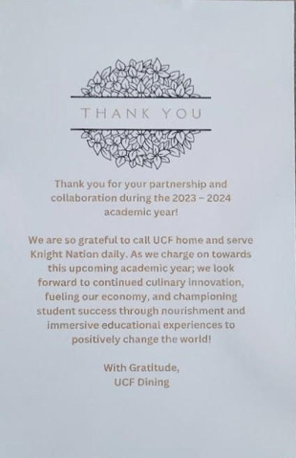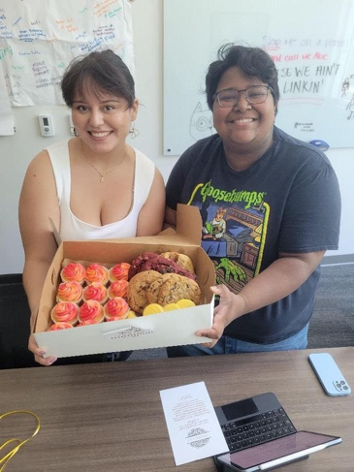
* **Confirmations**
  + [Confirmation Materials](https://ucf.sharepoint.com/:f:/s/UCFTeam-StudentGovernment_GRP-SGLegislative-Senate/EsmqNrTWb8NAi1o6IacCv2MB84_gpZUDP-mxyfCtAxLrvg" HYPERLINK "https://ucf.sharepoint.com/:f:/s/UCFTeam-StudentGovernment_GRP-SGLegislative-Senate/ElBjwGfqtVhEr1A4bamU9UgBQv8wriGpyZeQoF_2rQwxCQ?e=fxO0es)
  + None
* **Internal Legislation**
* **Notice of Legislation on First Reading** 
  + Constitutional Amendments
  + Bills
  + Resolutions
  + Proclamations
    - [Proclamation 56-07](https://ucf.sharepoint.com/:w:/s/UCFTeam-StudentGovernment_GRP-SGLegislative-Senate/EeYejG9NMV1Julc-SYCRdscBuO9ibSci1-uiqW-sutgoPA?e=ORmBtQ) [Proclamation Recognizing Women’s Equality Day] [DSR Lazo] **Remanded to SBA**
  + Special Acts
* **Notice of Legislation on Third Reading** 
  + Constitutional Amendments
  + Bills
  + Resolutions
  + Special Acts
* **Notice of Legislation on Second Reading**
  + Constitutional Amendments
  + Bills
  + Resolutions
  + Proclamations
  + Special Acts
* **Senate Forum**
  + None
* **Senate Deliberations**
  + Hameed: Senate wide initiatives for fall.
* **Advisor’s Report** 
  + Brodie:
    - End of the pay period for those in paid roles, please submit your time tonight!
    - I know Allison has mentioned it, but the summer will end in two more meetings and then we will have a long gap between meetings. If you have any proclamations or resolutions that will occur in August or September, I recommend getting those in asap, not to mention any fiscal legislation.
    - Senator Shout Outs (Out loud):
  + Maddie ([*sgasa@ucf.edu*](mailto:sgasa@ucf.edu)):
    - If you want to see something on the agenda, specifically legislation, you MUST CC me on the email notifying that the legislation is ready to be seen on first reading.
      * Please be using my student government email ([sgasa@ucf.edu](mailto:sgasa@ucf.edu)). This is my work email, if you use my personal UCF email there is a much higher chance of it being overlooked/lost.
* **Miscellaneous Business**
  + Reinstatements
  + Elections
  + Appointments
    - Inter-Campus & Transfer Ad Hoc Caucus
      * Adam Caringal
  + Resignations
    - Latin & Hispanic Caucus
      * Andrew Collazo
    - Women’s Caucus
      * Haleema Al-Qudah
    - Inter-Campus & Transfer Ad Hoc Caucus
      * Haleema Al-Qudah
    - Sustainability Ad Hoc Caucus
      * Chris Corelli
  + Jordan’s Joke:
    - Q: What does a house wear? A: Address 😀
  + Andrea’s Animal of the day:
    - 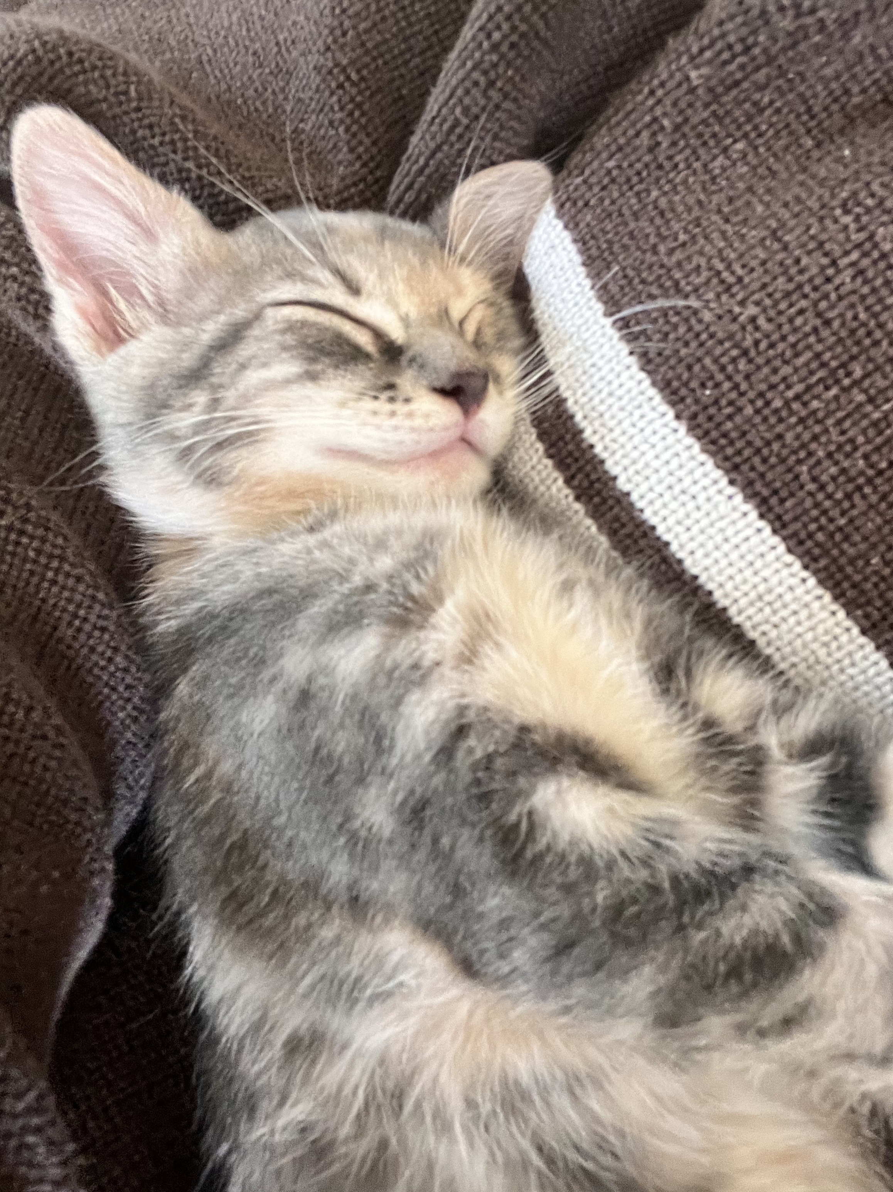
  + Laurel’s Lore: Laurel the lawntrepreneur
    - 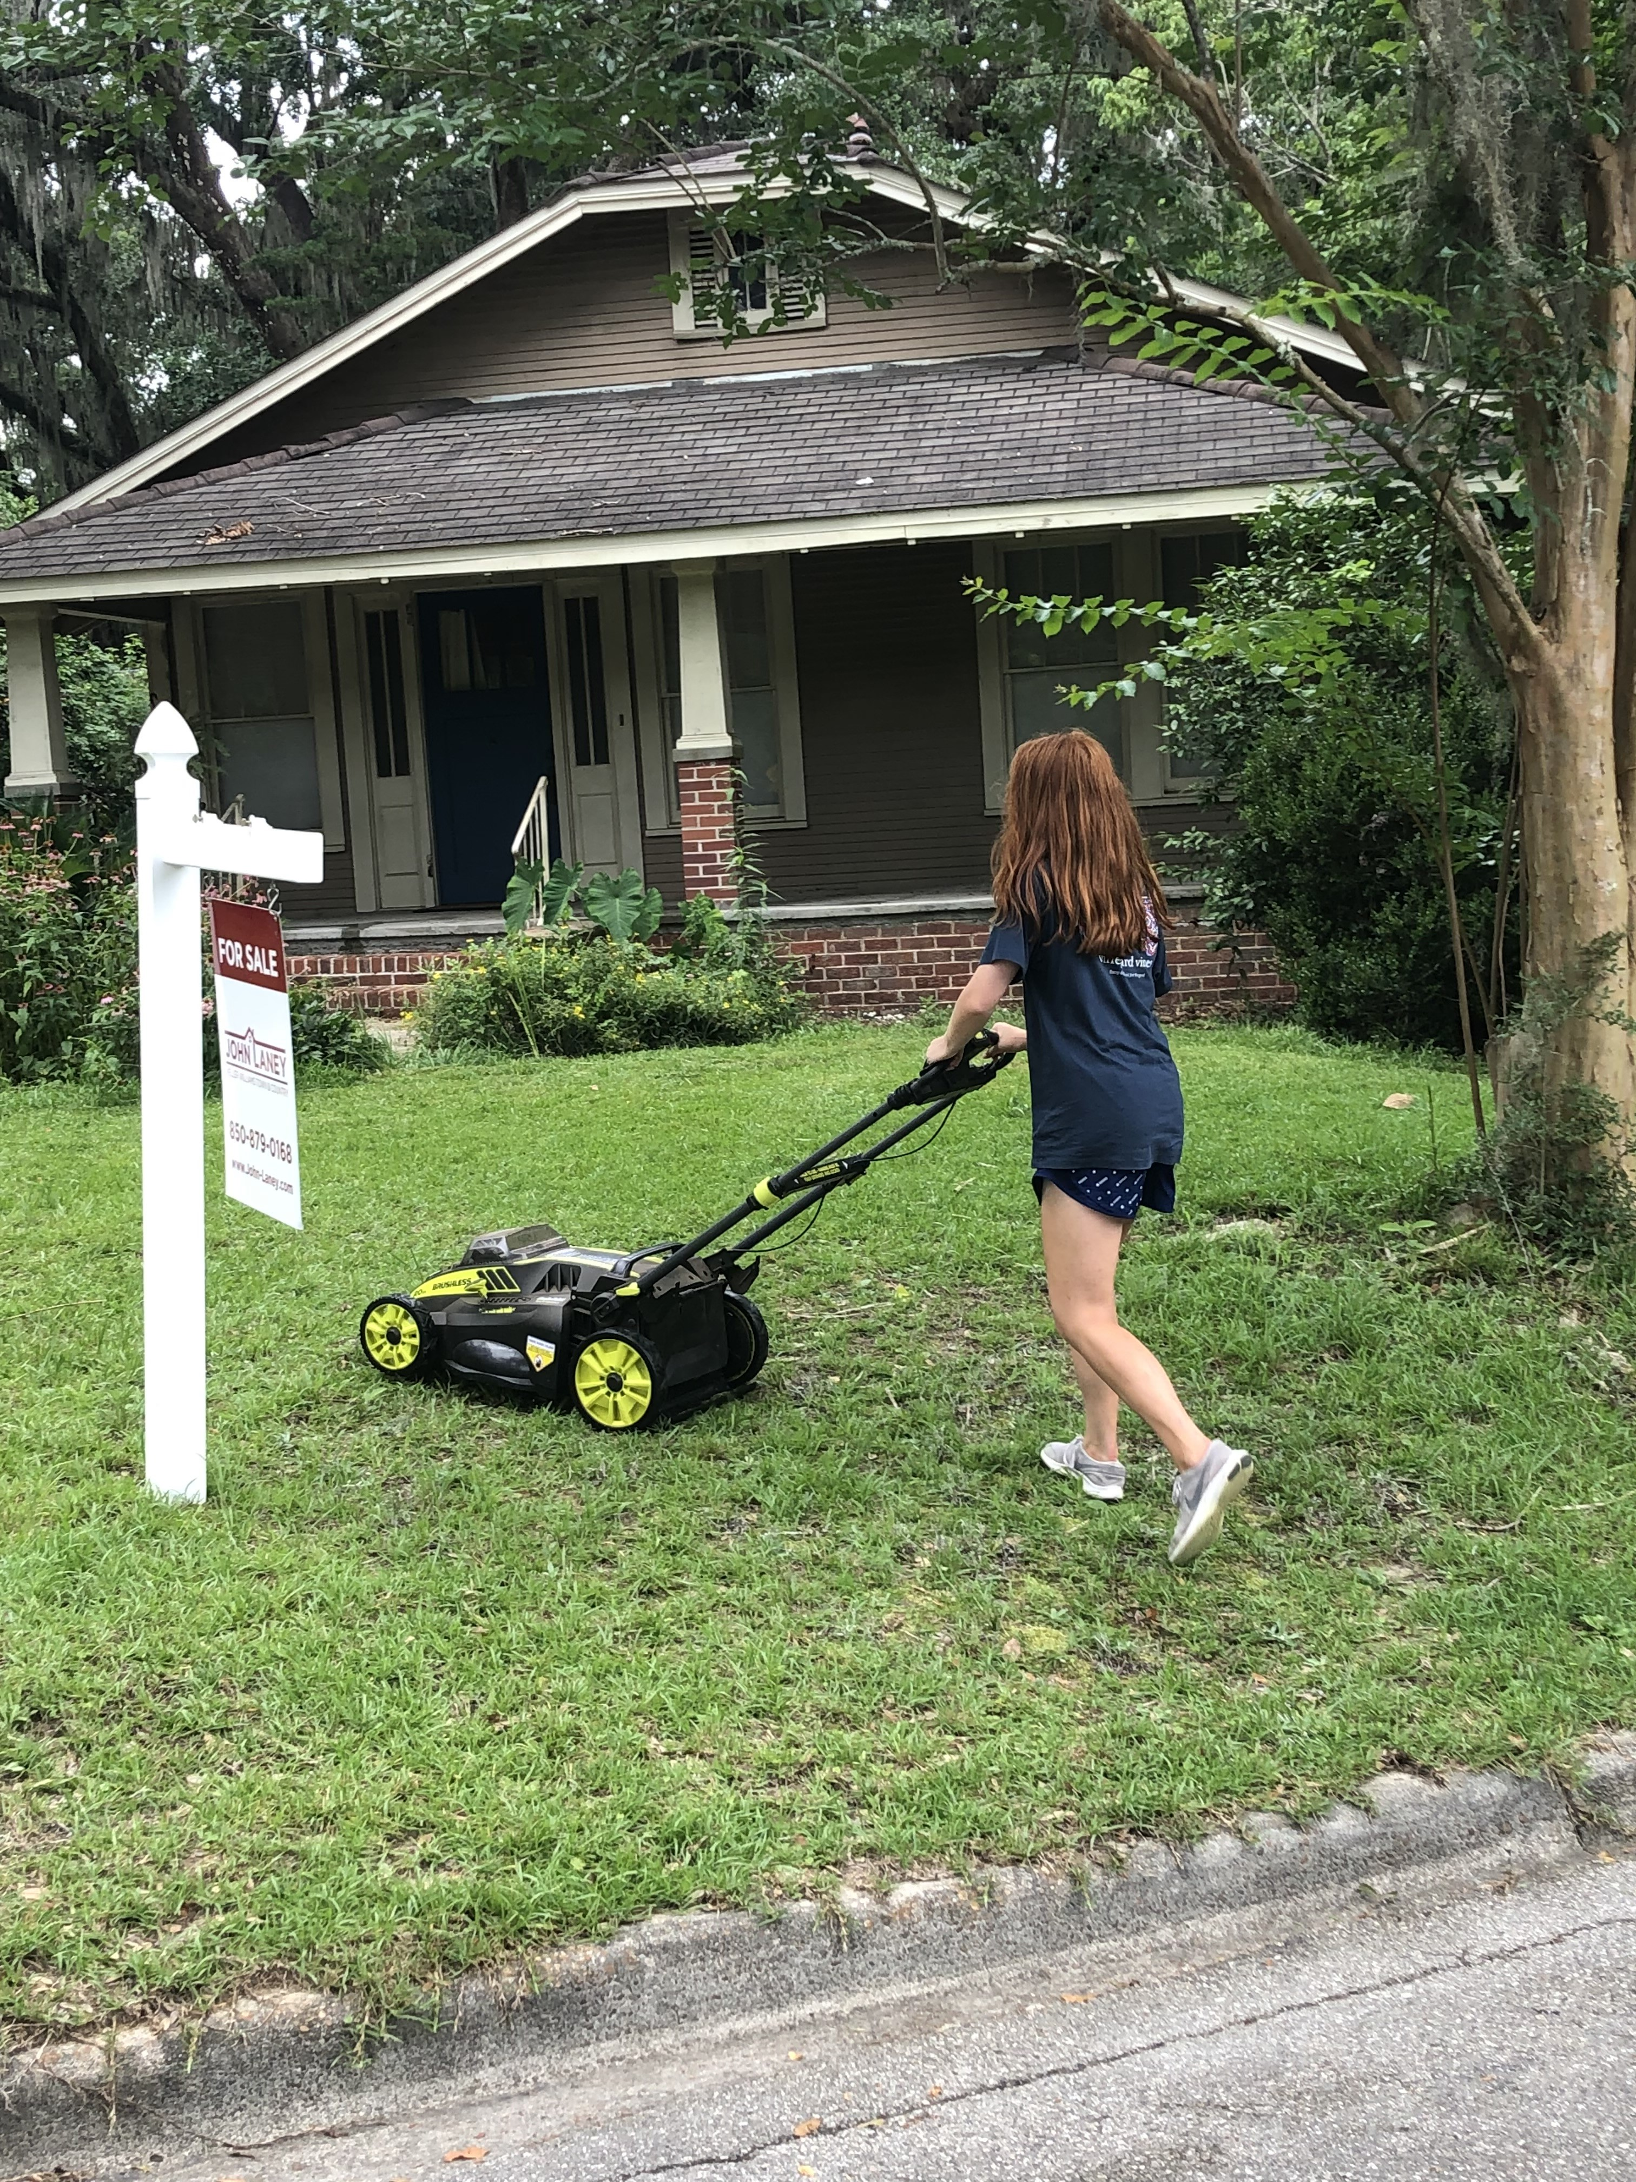
  + Dani’s Dope Drip:
    - 1st Place – Laurel
    - 2nd Place – Laurel
    - 3rd Place – Laurel
* **Final Roll Call**
  + 39/47
* **Adjournment**
  + 7:27 PM