MEETING AGENDA

# Call to Order: 12:03 pm

# Roll & Verification of Quorum (3): 3 /4

|  |  |  |  |
| --- | --- | --- | --- |
| **Name** | **Email** | **Initial** | **Final** |
| Chair Yracheta | sgdisabilitycaucus@ucf.edu | P | P |
| Vice-Chair Johnson | sgachps6@ucf.edu | P | P |
| Senator Hall | sga_grst3@ucf.edu | P | P |
| Comptroller Cimillo | sga_comp@ucf.edu | A | A |

# 

# Approval of the Minutes: approved by gc

# Approval of the Agenda: approved by gc

1. Open Forum: none
2. Announcements from the Chair:

Hello, thank you all for taking the time to attend this meeting. It will be brief. Today I want to discuss ideas on promoting better student engagement. Also, I will present a brief timeline of tentative proclamations/letters of support.

1. Announcements from the Vice-Chair:

Hi y'all! I had my first dean meeting the other day and he really liked my idea to incorporate subtitles into CHPS classes. He agreed to help me expand it to a school-wide initiative. I’ll also be meeting with Brodie to nail down my plan of action. I’m super excited to get this party started! Oh! And my proclamation on ASL day is going...

1. Announcements from Caucus Members:
2. Announcements from Non-Caucus Members:
3. Old Business:
4. New Business:
5. Initiative update: In communication with Cypress Knights, Emailed the Student Union building manager, and currently in communication with the Lighthouse of Central Florida
6. Tabling
   1. Advertise open seats
      1. Johson: Do we have merch?
      2. Hall: No, 2 years ago they used the money for a big event. Maybe we should partner with other caucuses. I think that speaker Pohlmann would prefer that. Is this a conversation happening on leadership level?
      3. Yracheta: Beneche is planning something like that.
      4. Hall: Johnson, can you talk more about your initiative?
         1. Johnson: Yes, I want a trial within CHPS and then spread to all colleges.
         2. Hall: Yes, good idea. Partner with SAS. It’s something we can all help with and it’s more of a long-term goal.
      5. Yracheta: I at least want us to be a caucus of 6. I’ll talk to them about tabling. I’ll keep up my initiative.
         1. Johnson: did you want to post on IG.
         2. Yracheta: I talked to Allison and the members can be anyone. I’d love to have some people from our interest RSO. I just want to wait a little longer to hear back from the RSO’s.
   2. Create flyers
   3. Anonymous drop box
   4. Sign-up sheet for newsletter
      1. Johnson: I don’t want it to be hard to keep up with.
      2. Hall: Are these students upset about the cancelled meeting in a Disability RSO?
      3. Yracheta: I didn't ask. The emails were very apologetic.
      4. Hall: In the Arab Caucus the chair is getting the heads of those RSO, and setting up a group chat to keep them informed. There is only so much we can do. It’s going to grow... Technically all meetings are posted but no one checks it. The bare minimum is making sure we post the minutes ASAP. We really need to commit.
   5. Banner:

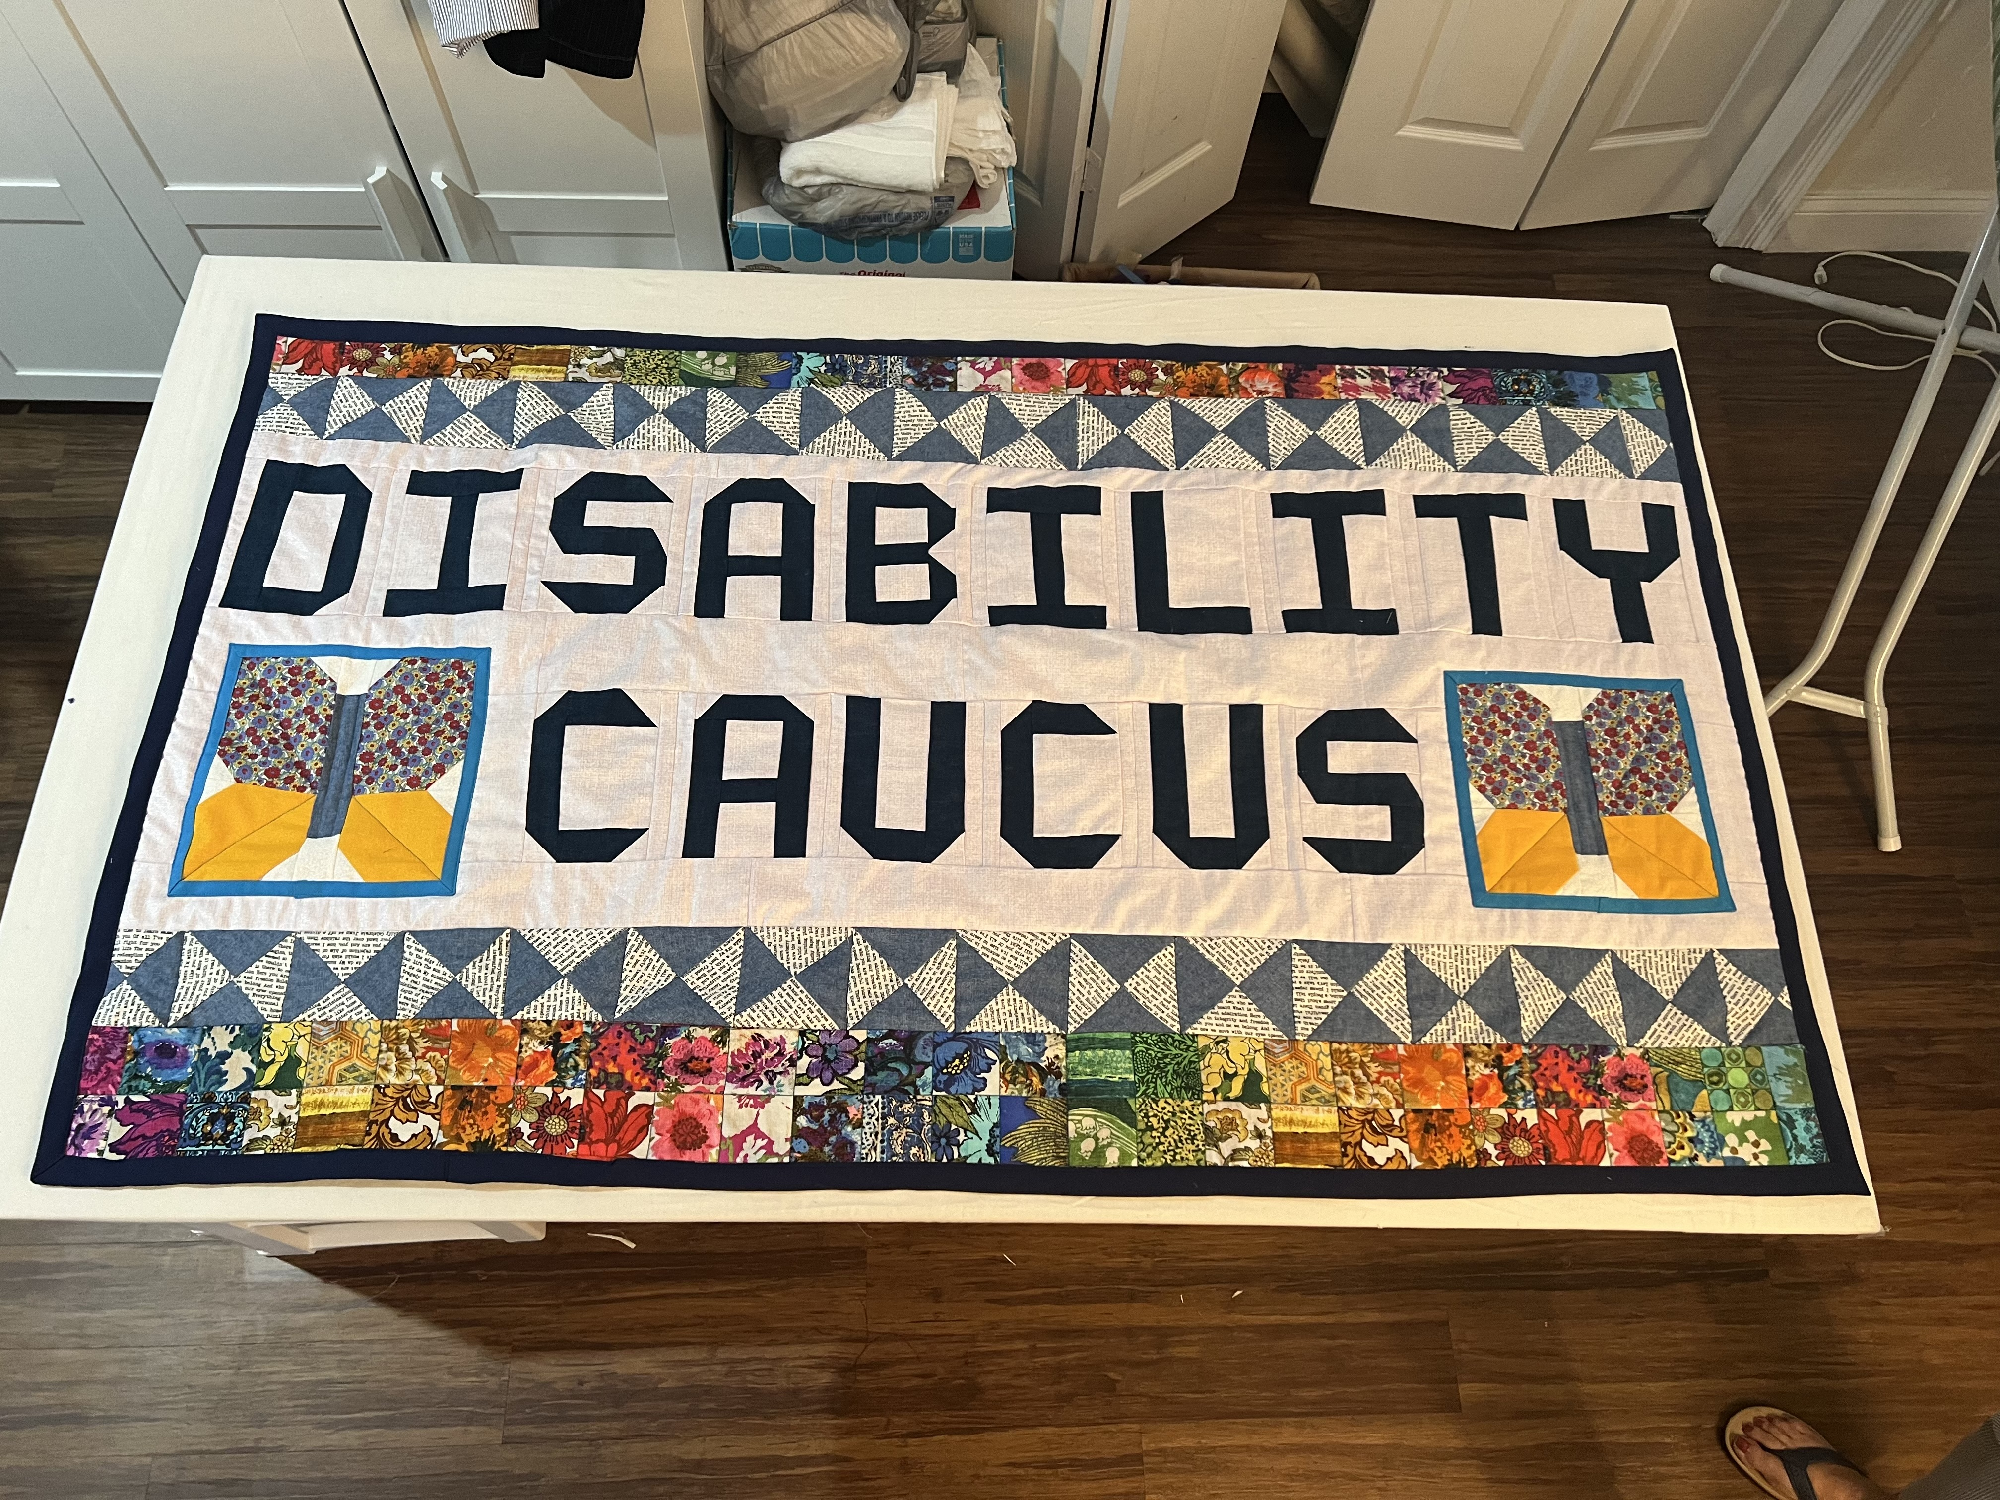

1. Monthly newsletter via email
   1. Share news about upcoming events/ proclamations/ other updates
2. Proclamation timeline:
   1. <https://docs.google.com/document/d/1gccVpKEkYP1gBgCqgPC2-Kh4sIK4IfWZ84wLy8wCbfA/edit?usp=sharing>
      1. Johnson: For October, ADHD Month, could we do Trick or Treating? It's cost-effective.
      2. Yracheta: Super easy. It could be super fun.
      3. Johnson: Are we going to be education based? Do we want to tie it in with events?
      4. Yracheta: It up the chair. We can always get people to come and speak and make it cost effective. We could partner with RSO. Lots of possibles for events.
      5. Hall: It’s a balancing act. It's usually Exec that hosts lots of events. The goal needs to be education, but we need to have incentives. The Latin caucus held a block party, and it was awesome. I love letters of support. We don't need to be the most forward-facing caucus. A lot of the real work is behind the scenes. We need to express our concerns and ideas. Let’s do intentional events. I like that we are doing it behind the scenes. We have passed a lot of proclamations, and we didn't do that a lot in past sessions. Proclamations should be done after or while the *work* is being done. For ADHD let's speak with SAS and see what they’re doing. What’re the students’ concerns?
      6. Yracheta: We are not well known. When I was talking to the SAS director, the best year that had was when the students knew that they could come to us and express their concerns. We want to build confidence and that's my goal.
      7. Johnson: Should I pair my proclamation with my live subtitle initiative?
      8. Hall: Not necessarily. I don’t want to discourage you. I don’t think this is a bad idea. A proclamation should be a starting point. You might want to get some feedback from CHPS so that it’s factually accurate.
3. Member Discussion:
4. Miscellaneous Business:
5. Final Roll Call: 3/4
6. Adjournment: 12:42pm

# Key:

P - Present

A - Absent

MTD - Move to Debate

MTV - Move to Vote

MTA- Move to Amend

PP - Postpone

PPI - Postpone Indefinitely

GC - General Consent